
SUBJECT : software construction and development LAB
ASSIGNMENT NO : 3
NAME : MOIN UD DIN
ID : CU-4365-2023
SECTION:D
DEPARTMENT: SOFTWARE ENGINEERING

- Input three numbers and print the largest.
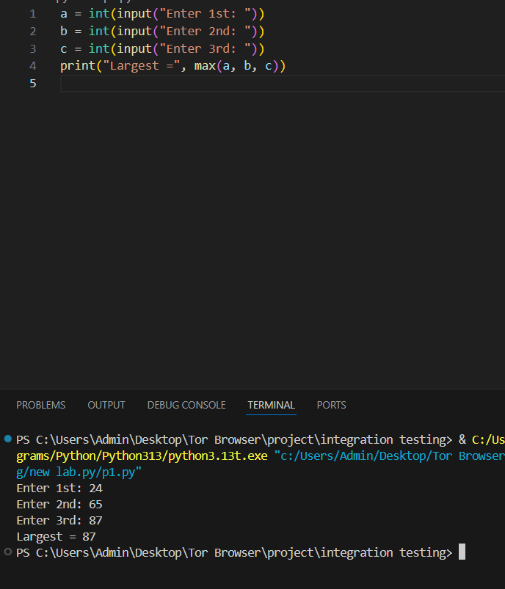

- Check if number is positive, negative, or zero.
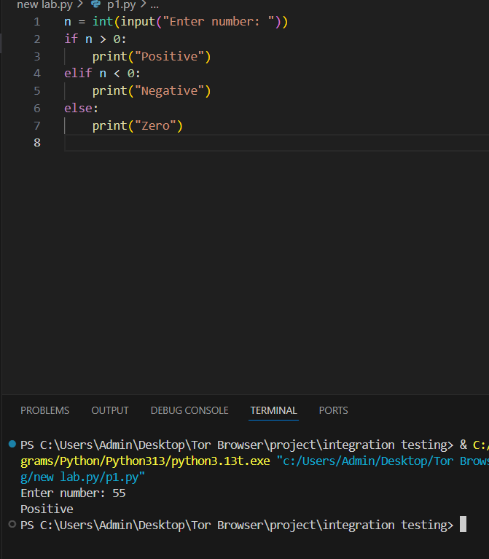

- Discount program
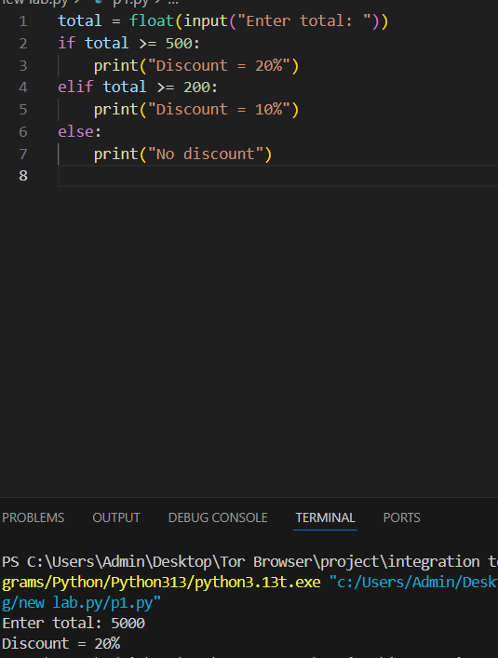

- Username & password login
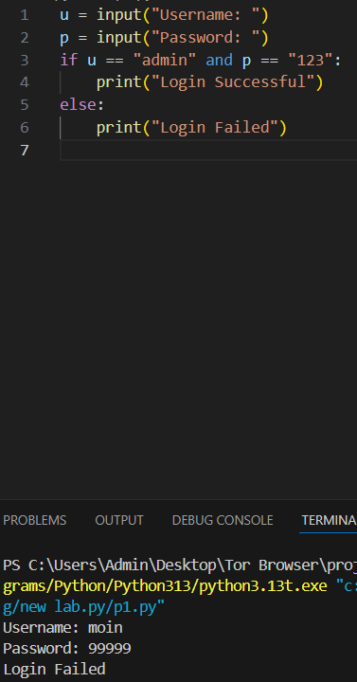

- Password strength checker.
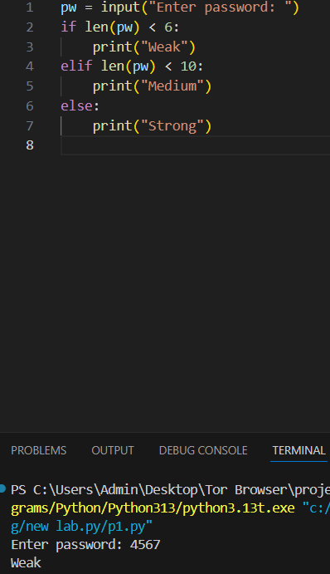

- Speed fine program.
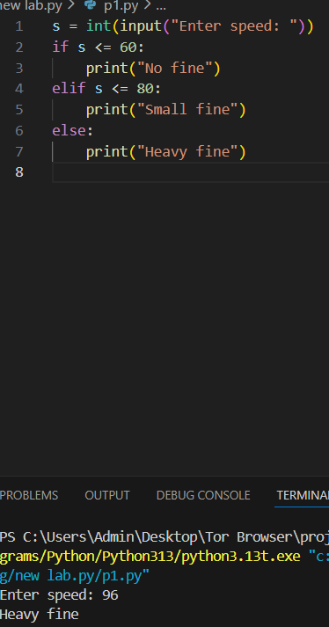

- Weather classification
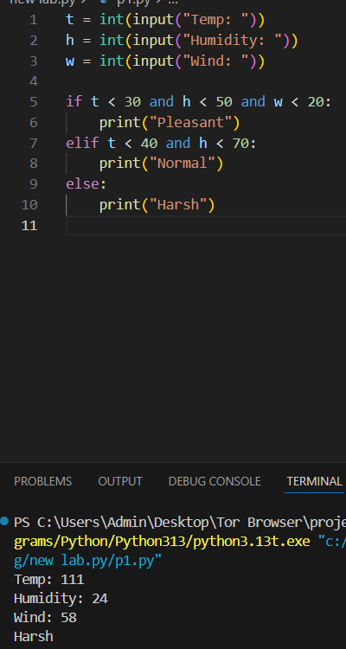

- Even numbers 1–50 (for loop)
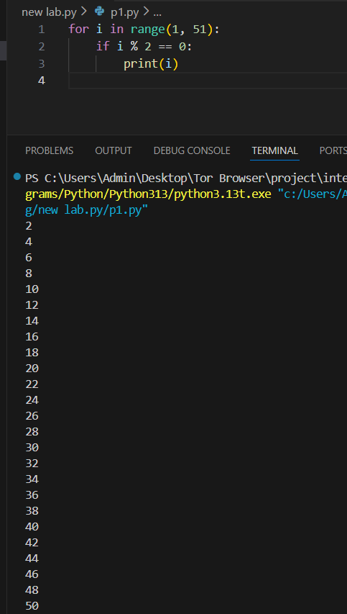

- Squares of 1–10
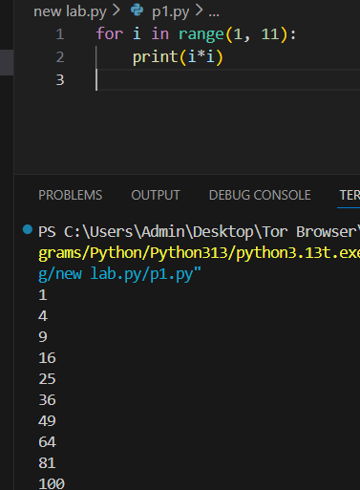

- Count vowels in a string
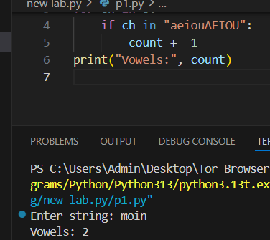

- Print marks > 50
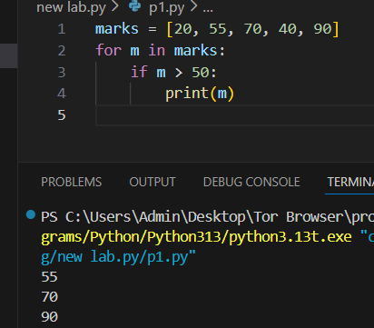

- Multiplication table
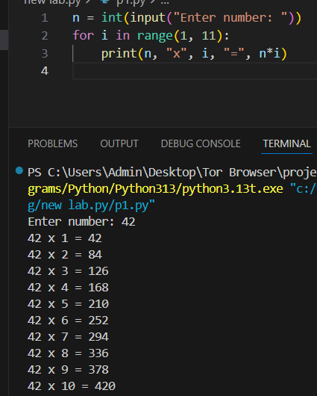

- Odd numbers 1–20 (while loop)
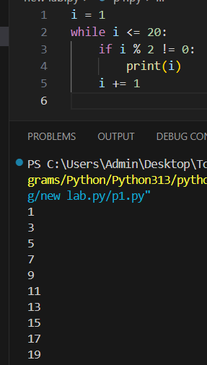

- Ask for password until correct
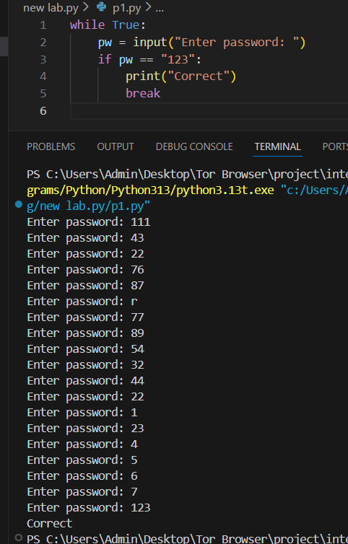

- Keep taking input until user types "stop"
